Advance Software Engineering Lab Report (Lab-Id 5_1)

Name: Harika and Sumanth

Class Id: 15, 20

Team number: 5_1

ICP team: 5

ICP 4 question :

Create a simple ionic application using any of the ionic templates [tabs, sidemenu]

Approach

Creating an application having sign up and login activities and the Main page extracts the data from Mashup of at least Two Web Services

Input

Knowledge Search and Image Search.

Output

Gives name, resultscore and description of knowledge search.

Shows the images of the input(image search).

Code Explanation

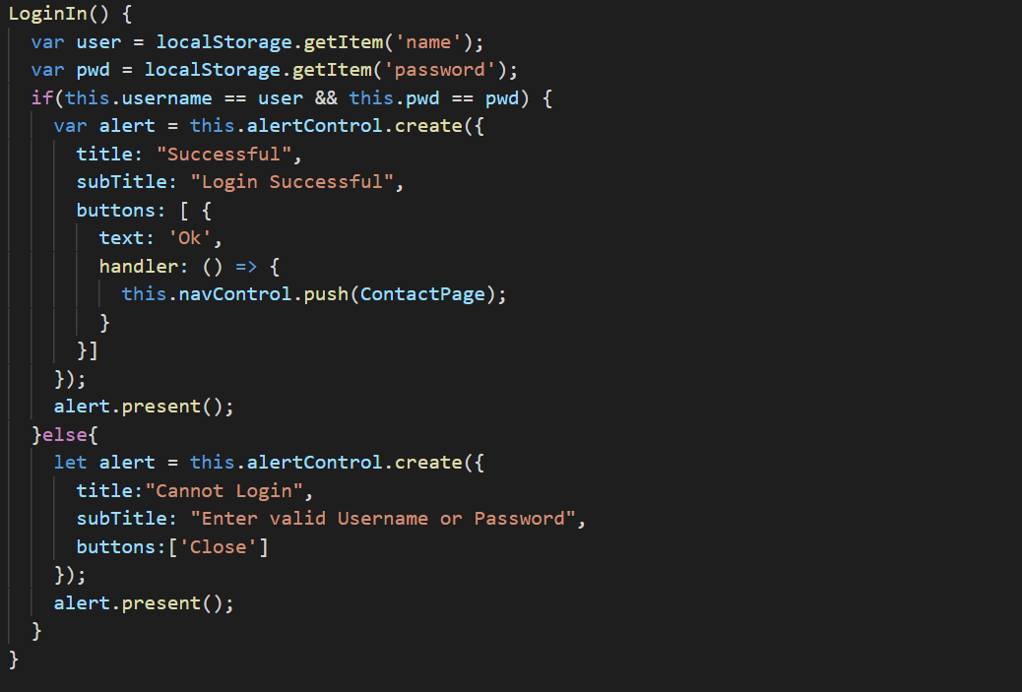

Login method has been implemented by using localStorage.

Login method will checks for locally stored user details for validation and the navigates to Dashboard Tab accordingly.

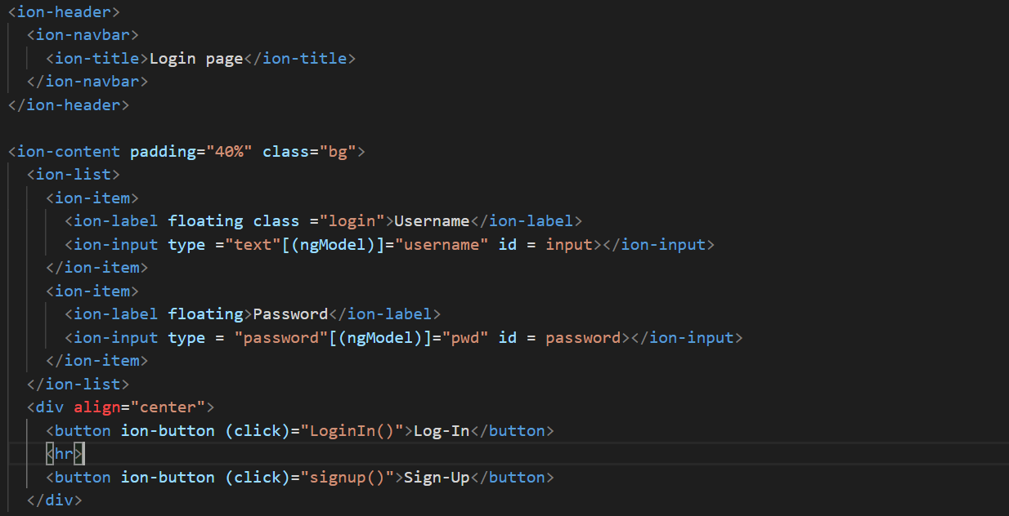

In the above code, Login method is called using the frontend where it is implemented using ionic tags.

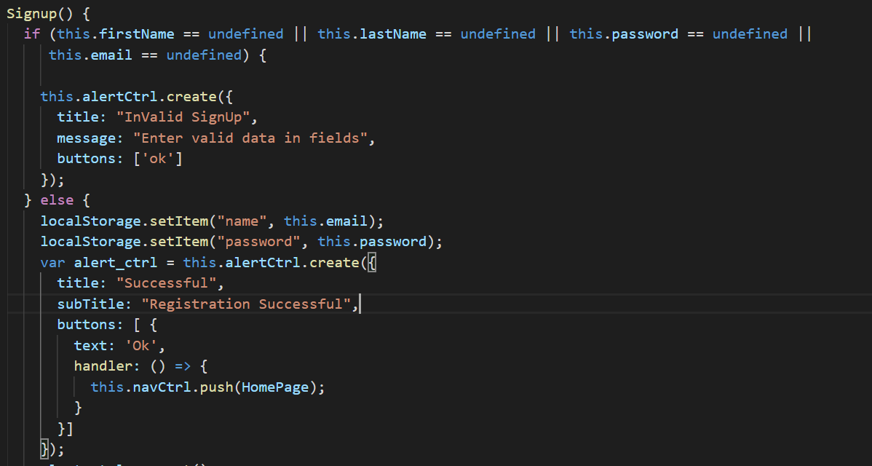

Signup method is created to save the user details in localstorage and checks for valid or invalid inputs and then set the localstorage.

Post successful registration the user will be redirected to the Login Page.

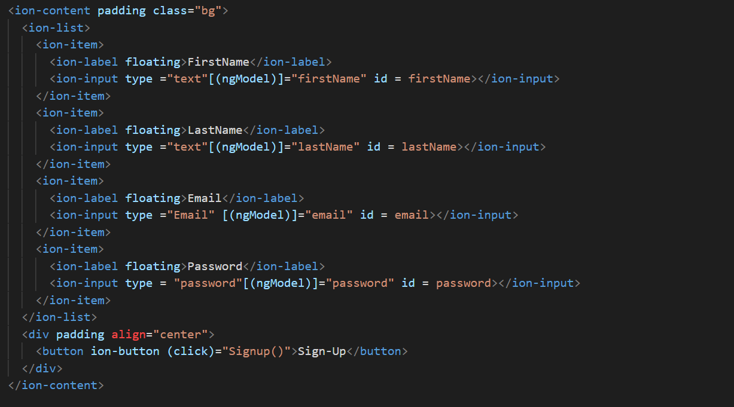

In the above code signup method is called upon button click.

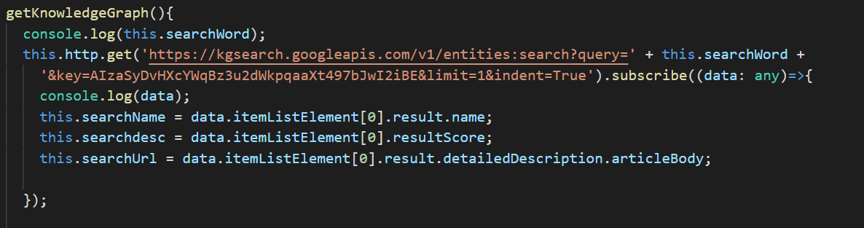

From google KnowledgeGraph API, we are displaying name, result and Description.

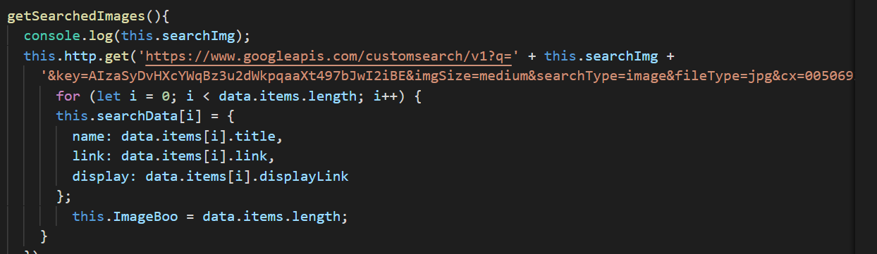

From Google CustomSearch API, we are displaying the images.

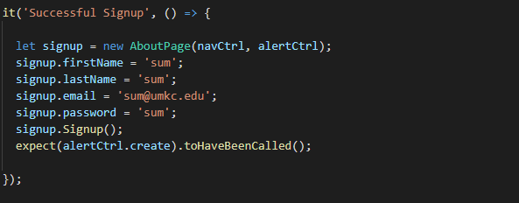



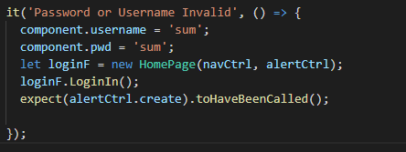

Above are the unit test cases for Login and Signup Functionalities.

